Pac-Poly-Amsterdam Island



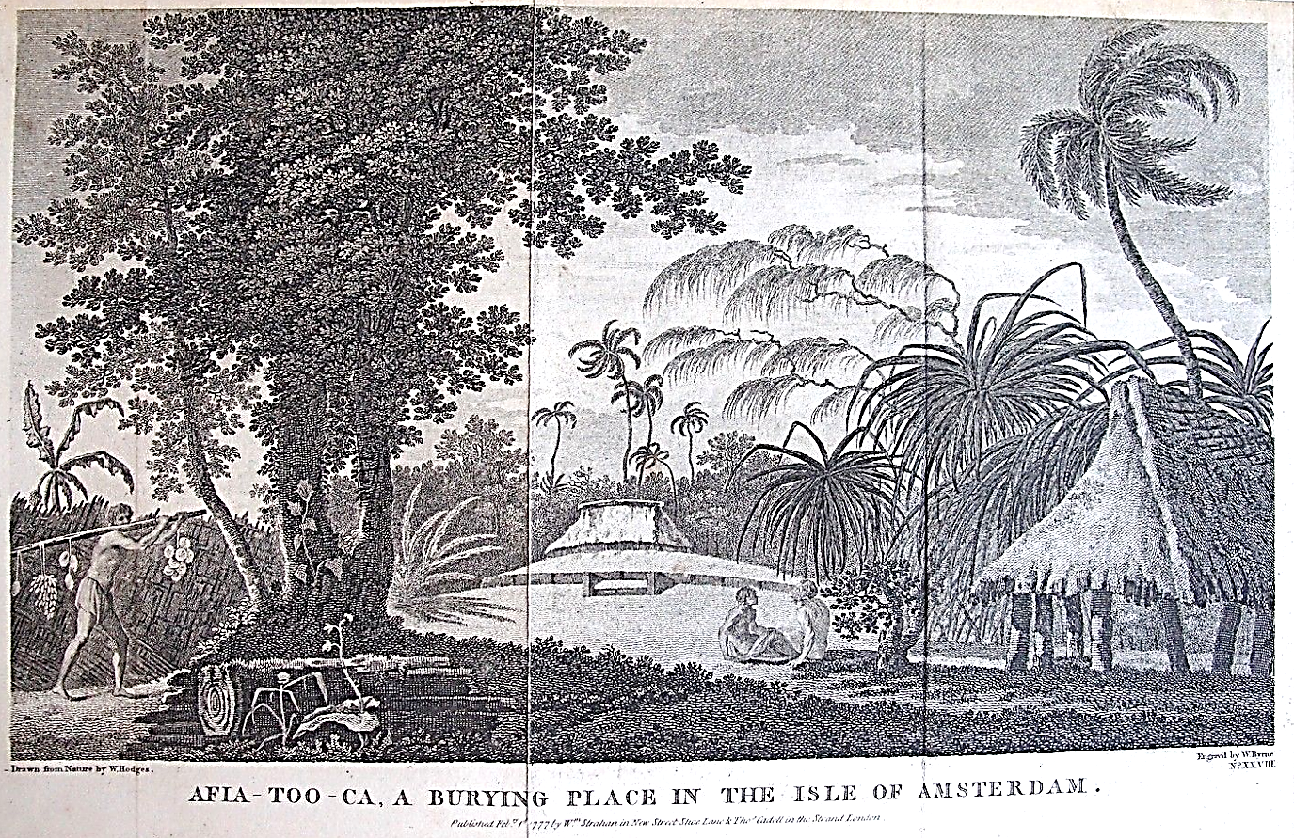

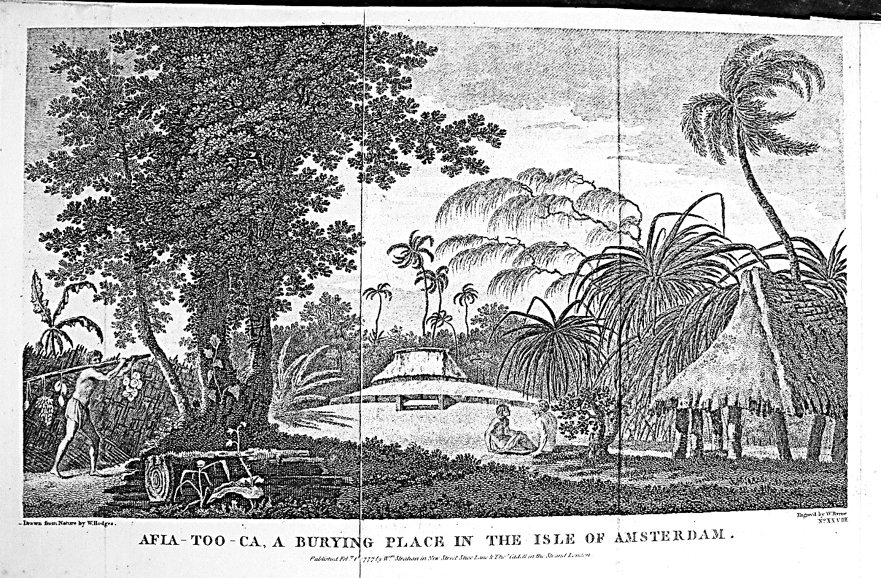

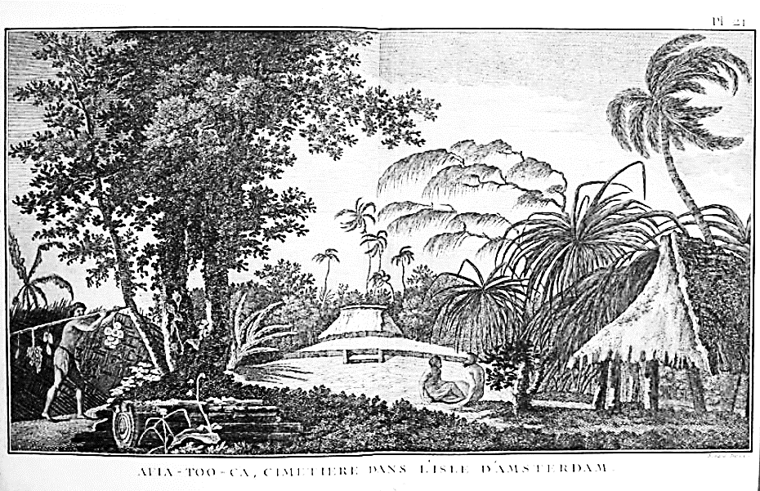

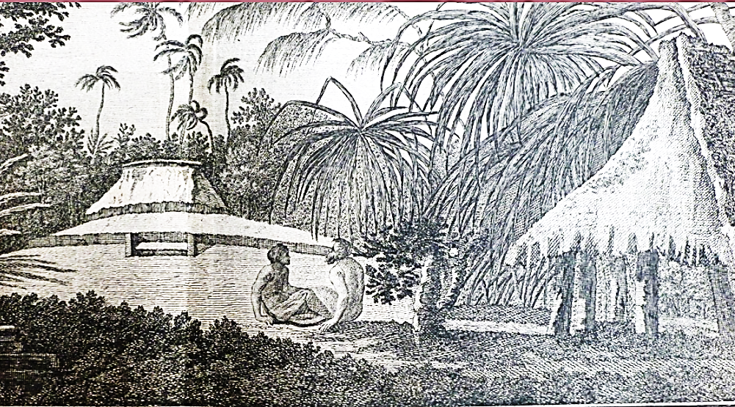

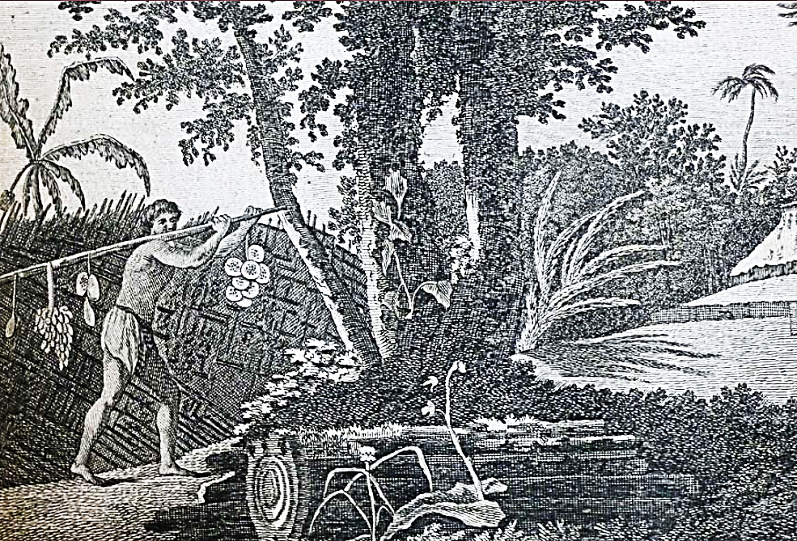

COOK, James. Travel in the southern hemisphere and around the world...(Second trip)  
Paris: Hotel Thou, Engraved by BERNARD 1778 Engraving on copper  
Thick paper in good condition

